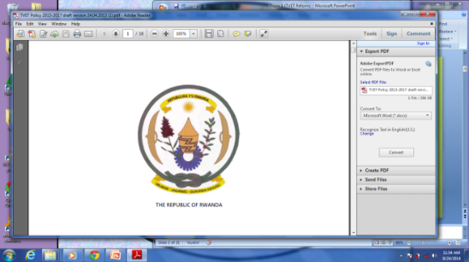**Republic of Rwanda**

**Ministry of Education**

**TVET DISTRICT COMPREHENSIVE ASSESSMENT**

**ACADEMIC YEAR 2021-2022**

**EXAM TITLE: Graphic Design Basics /100Marks**

**RTQF LEVEL III**

**OPTION: Computer Applications**

**DURATION: 3HOURS**

**DATE: …./……./…………**

**INSTRUCTION TO CANDIDATES:**

**This exam has three section A, B and C**

**Section A: Answer all questions 55Marks**

**Section B: Choose Three Questions 30Marks**

**Section C: Compulsory question 15Marks**

**Erasure for multiple choice question, you loose marks for it**

**ANSWER SHEET:**

SECTION ONE: Answer all questions 55Marks

**1. Explain the following key features of digital image. 12Marks**

1. Pixel
2. Resolution
3. Lossy image file compression
4. Lossless image file compression
5. Raster graphics
6. Vector graphics

**Answer:**

**Pixel:** The term **pixel** is short for "picture element", and **pixels** are the tiny building blocks that make up all digital images.

**Lossy compression:** is a method of data compression in which the size of the file is reduced by eliminating data in the file. In doing so, image quality is sacrificed to decrease file size.

­ **Lossless compression:** is a compression technique that does not lose any data in the compression process.

**Resolution:** refers to the number of pixels in an image. Resolution is sometimes identified by the width and height of the image as well as the total number of pixels in the image. For example, an image that is 2048 pixels wide and 1536 pixels high (2048 x 1536) contains (multiply) 3,145,728 pixels (or 3.1 Megapixels).

**Raster graphics**: a type of digital image that uses tiny rectangular pixels arranged in a grid formation to represent an image.

**Vector graphics** are computer images created using a sequence of commands or mathematical statements that place lines and shapes in a two-dimensional or three-dimensional space.

**2. state the three-color modes you know. 3marks**

**Answer:**

* RGB
* CMYK
* Grayscale

**3. What are the important qualities of graphic designer? 6Marks**

**Answer:**

* Analytical skills
* Artistic ability
* Communication skills***.***
* Computer skills
* Creativity
* Time-management skills

**4. How can you capture a digital image? 4Marks**

**Answer:**

* Saving image from a digital camera
* Using print screen
* Saving image from website
* Using a scanning application and scan an image

**5. what do you understand by Typography? /3Marks**

**Answer:**

* **Typography** is the art of expressing ideas in printed form through the selection of appropriate typefaces.

**6. State 7 design elements /7Marks**

**Answer:**

* Color, line, shape, value, form, texture, space

**7. A 500 dpi image that measures 7 inches by 6 inches and 16 bits, what is its size in megabytes? /5Marks**

**Hint:** 

**Answer:**

* (7 x 6 x 16 x 5002)/8 = 21,000,000 bytes
* 21000000/1024 = 20507.8125 Kilobytes
* 20507.8125/1024 = **20.03** Megabytes

**8. Multiple choice (write correct letter only) /15Marks**

1. For What work Photoshop is used ?

**A** For Graphics

**B** For Animation

**C** For Programming

**D** For Typing

1. What is File Extension in Photoshop?

**A** Bmp

**B** Tiff

**C** Psd

**D** Txt

1. What is the meaning of CMYK?

**A** Cream Magenta Yellow Kole

**B** Cyan Magenta Yellow Blue

**C** Cyan Magenta Yellow Brown

**D** Cyan Magenta Yellow Black

1. Which color mode is used for printing?

**A** RGB

**B** CMYK

**C** Gray Scale

**D** All of the above

1. By using which of these options, a new file is created in Photoshop

**A** File > New

**B** File > Open

**C** Create > New

**D** Start > New File

1. What is the shortcut key to create a new file in Photoshop?

**A** File, new

**B** Ctrl + N

**C** Ctrl+Shift+N

**D** Shift+N

1. What types of graphics are made of Pixels?

**A** Raster Image

**B** Vector Graphics

**C** A and B Both

**D** None of these

1. Which of these color models is not in Photoshop?

**A** RGB

**B** LAB

**C** CNYK

**D** HSB

1. What is the shortcut key to create a duplicate layer of a layer?

**A** Ctrl+J

**B** Ctrl+T

**C** Ctrl+N

**D** Ctrl+D

1. Which menu contains the duplicate layer option in Photoshop?

**A** Image

**B** Layer

**C** Filter

**D** All of the above

1. Full form of DPI-

**A** Dots per inch

**B** Dots per ink

**C** Disk Point Inch

**D** Display per inch

1. What is the full form of RGB ?

**A** Red Green Black

**B** Red Gray Black

**C** Red Green Blue

**D** All of the above

1. The full form of GIF –

**A** Graphics Interchange Format

**B** Graphics inter file

**C** Gray-scale Interchange file

**D** Graphics Interchange file

1. What is the meaning of S in HSB color model ?

**A** Color

**B** Saturation

**C** Brightness

**D** All of these

1. What kind of colors are red, yellow and blue?

**A** Primary

**B** Secondary

**C** Tertiary

**D** Complementary

SECTION TWO: Choose Three Questions 30Marks

**9. List and explain in brief any 5 graphic design principles 10Marks**

**Answer:**

a) **Balance:** Balance is an equal distribution of weight. In terms of graphics, this applies to visual weight. Balance is vital to the success of a design.

**There are two main types of balance:**

***i) Symmetrical balance*** is an arrangement of elements so that they are evenly distributed to the left and to the right, or top and bottom of center.

***ii) Asymmetrical balance*** is an arrangement of unlike objects of equal weight on each side of the page. Color, value, size, shape, and texture can be used as balancing elements.

**b) Proximity**

The Principle of Proximity states that you *group related items together*, move them physically close to each other so the related items are seen as one cohesive group rather than a bunch of unrelated bits.

**c) Alignment**

The Principle of Alignment states, **"Nothing should be placed on the page arbitrarily. Every item** **should have a visual connection with something else on the page."**

When items are aligned, the result is a stronger cohesive unit. *The basic purpose of alignment is to unify and organize the page.*

**d) Repetition**

The Principle of Repetition states, **"Repeat some aspect of the design throughout the entire piece."** The repetitive element may be a boldfont, a thick line, a certain bullet, color, design element, particularformat, spatial relationship, etc.

**e) Contrast**

Contrast is the most effective way to add visual interest to your page. The Principle of Contrast states, **"If two items are not exactly the** **same, then make them different. Really different."**

**10. Identify graphic design steps /10Marks**

**Answer:**

1. Define Problem
2. Research/generate ideas
3. Identify criteria and constraints
4. Explore possibilities
5. Select an approach
6. Develop a design proposal
7. Construct a Model or prototype
8. Test and evaluate
9. Refine
10. Create or make
11. Communicate results

**11. a) Identify basic elements of creative belief /5Marks**

**Answer:**

* Background information
* Project Description
* Project Objectives
* Target Audience
* Competition
* Project details

**b) Describe graphic design ideas generation /5Marks**

**Answer:**

* **Ideation techniques**

Ideation is at the heart of the Design Thinking process.

* **Thumbnail sketches**

Art directors, storyboard artists and graphic designers, as well as other kinds of visual artists, use the term "thumbnail sketch" to describe a small drawing on paper (usually part of a group) used to explore multiple ideas quickly.

* **Rough sketches**

**Rough** drawing representing the chief features of an object or scene and often made as a preliminary study.

* **Finished sketches**

A '**finished**' artwork is a piece that has been worked to a particular level of detail.

* **Comprehensive sketches**

**12. To work with photoshop you have to know it and its interface, so define Photoshop and mention the following parts. 10Marks**

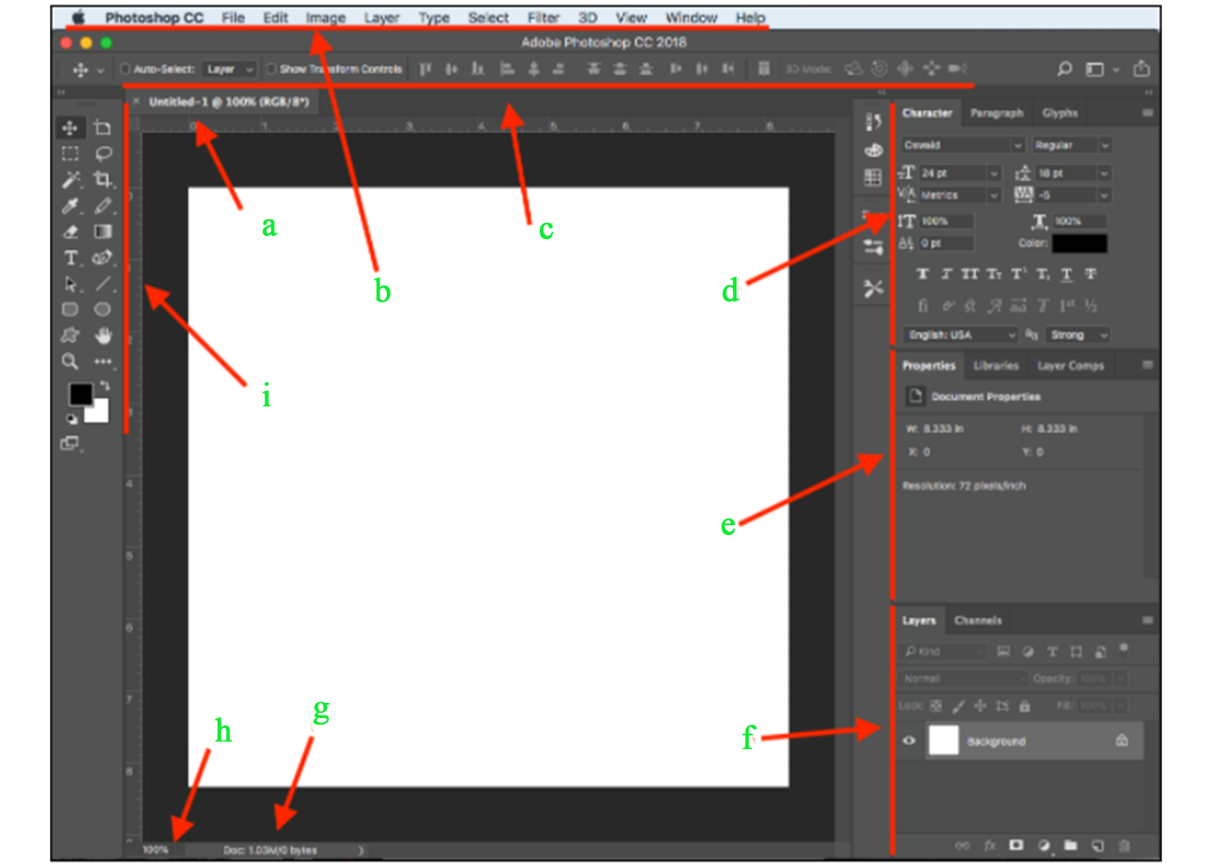

**Answer:**

**Adobe Photoshop** is a software application for image editing and photo retouching for use on Windows or Mac OS computers.

**Those parts are:**

* 1. Document tab
  2. Menu bar
  3. Options bar
  4. Character palette/panel
  5. Properties panel
  6. Layers panel
  7. Status bar
  8. Zoom level
  9. Tools panel

**13. With adobe illustrator: /10Marks**

**a. how to restore preferences?**

**Answer:**

* Press and hold **Alt+Control+Shift** (Windows) or Option+Command+Shift (macOS) as you start Illustrator

**b. how to rename or duplicate a workspace?**

**Answer:**

1. Choose Window > Workspace > Manage Workspaces.
2. Do any of the following, and then click OK:

* To rename a workspace, select it, and edit the text.
* To duplicate a workspace, select it, and click the New button.

**c. how to show or hide guides?**

**Answer:**

* To show or hide guides, choose View > Guides > Show Guides or View > Guides > Hide Guides.

**d. how to create an artboard?**

**Answer:**

* To create a custom artboard, select the Artboard tool https://helpx.adobe.com/content/dam/help/en/illustrator/using/artboards_icon.png, and drag in the document to define the shape, size, and location.

**e. how to merge shapes?**

**Answer:**

* To do so, you will need to open the pathfinder tool. To find it, go to **Window > Pathfinder**, and the toolbox will pop up.
* Select the objects that you want to merge, then select **Merge** from the pathfinder toolbox.

SECTION THREE: Compulsory question 15Marks

**14. As a graphic and book designer, you should know some softwares to use including illustrator and InDesign,**

**a. specify these parts labelled by letters in that InDesign interface below /8Marks**

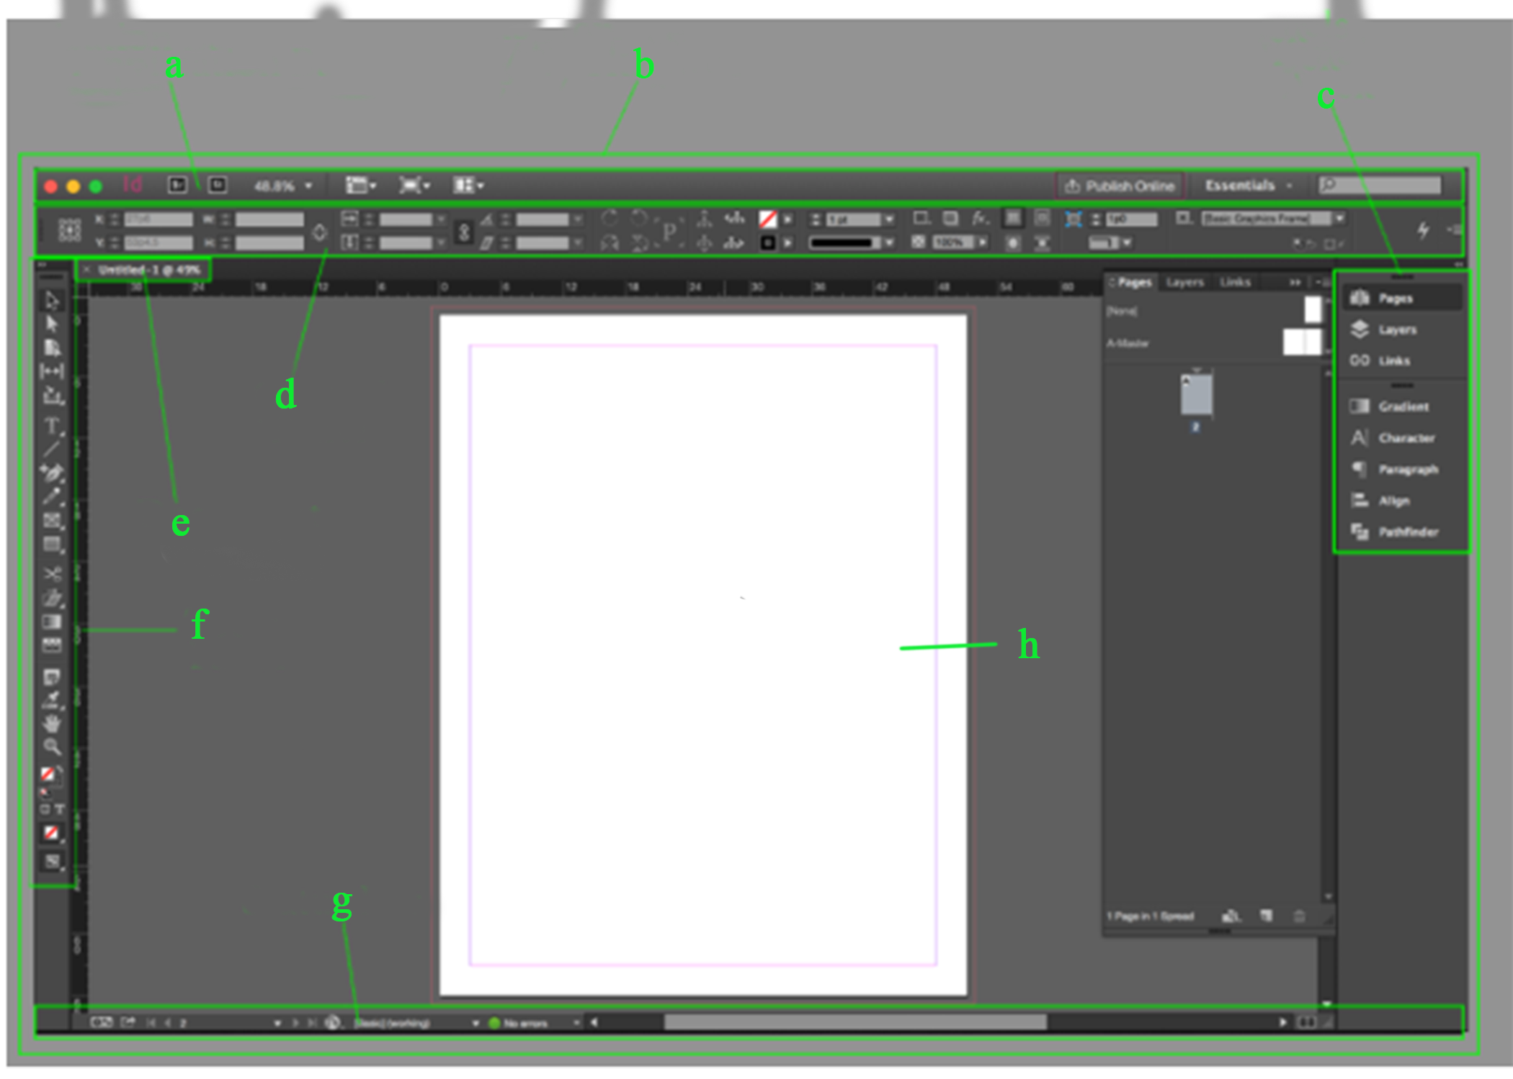

**Answer:**

1. Application bar
2. Workspace
3. Panels dock
4. Control panel/ bar
5. Document tab
6. Tools panel
7. Status bar
8. Document window

**b. specify these parts labelled by letters in that Illustrator interface below /7Marks**

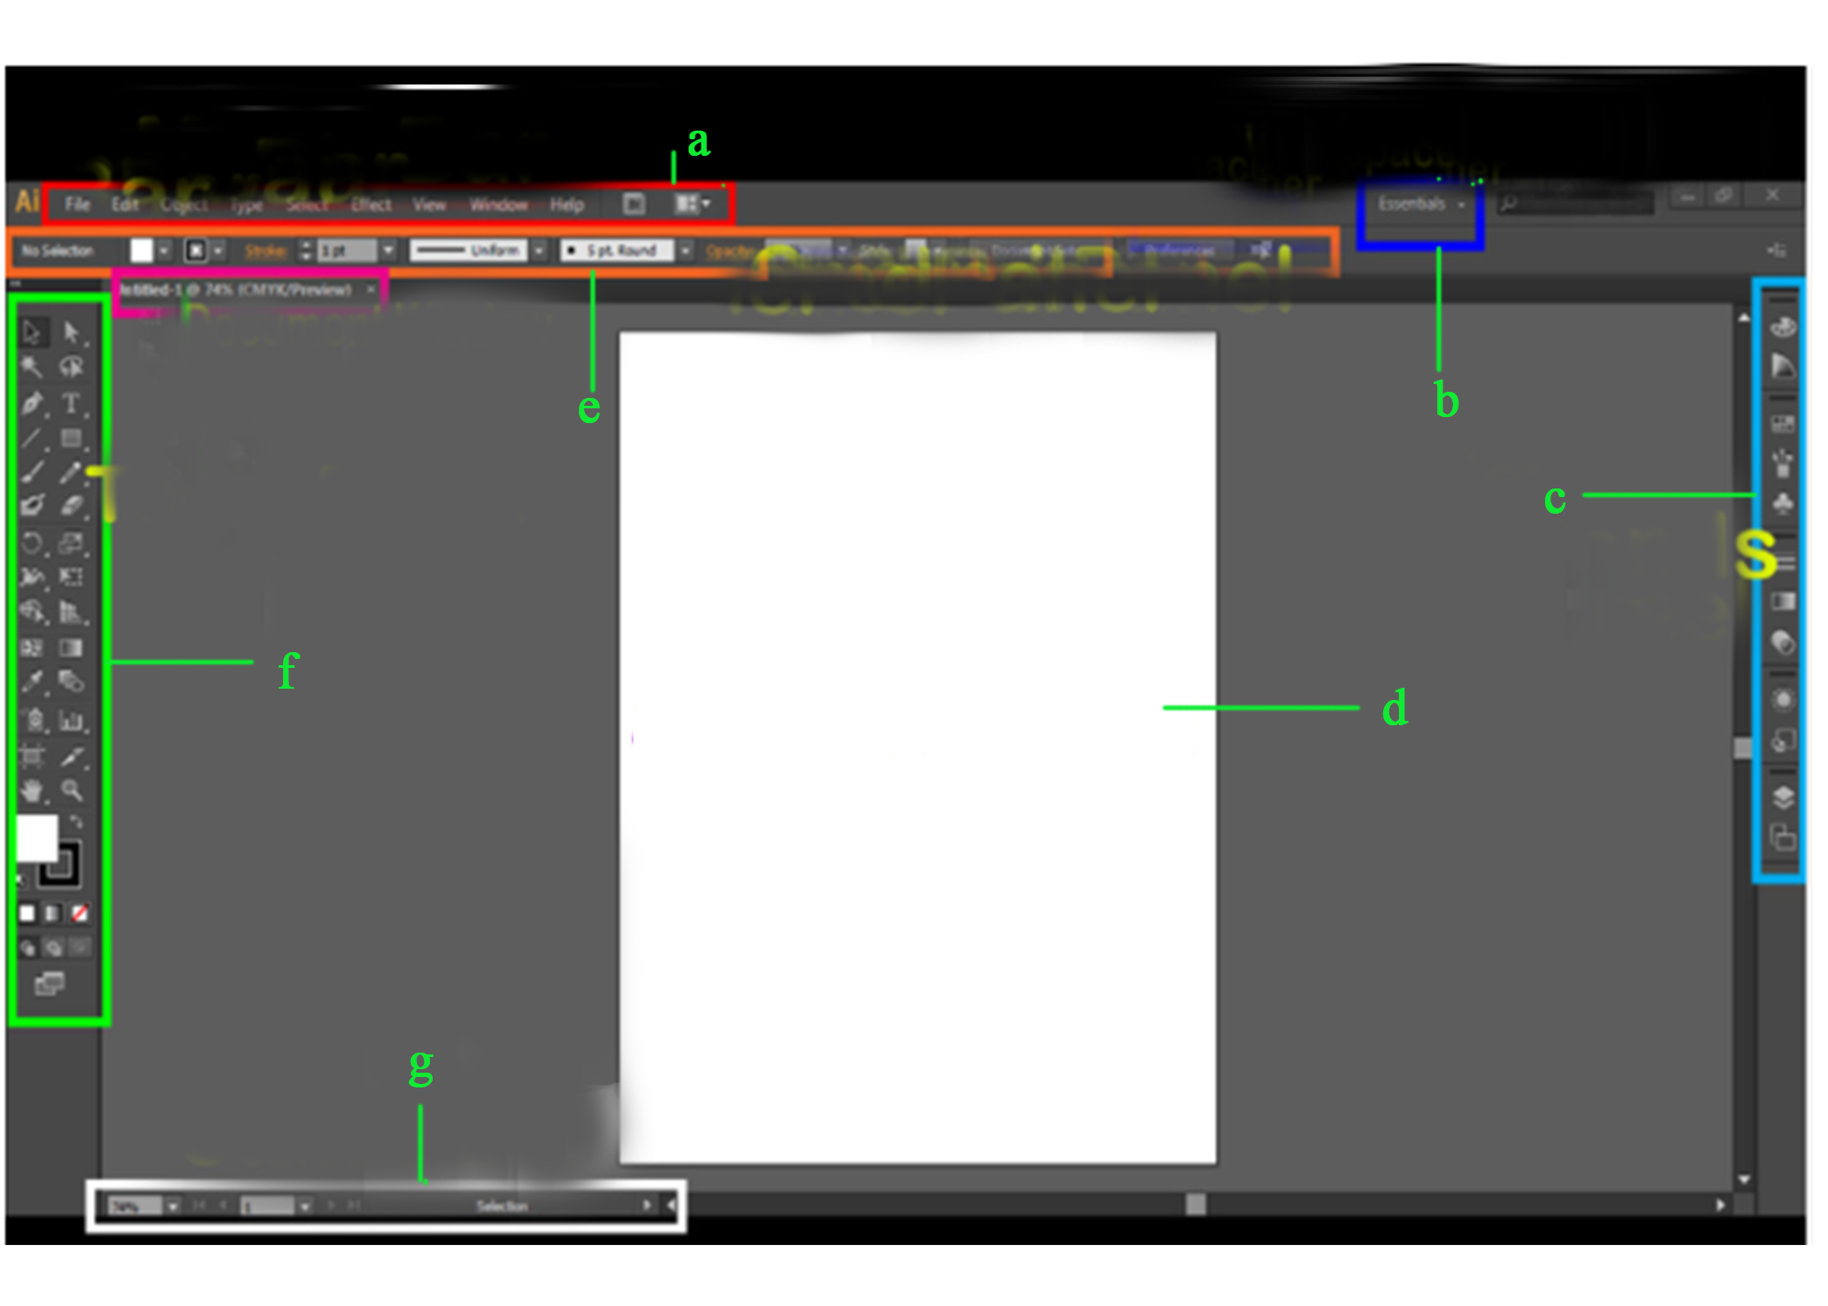

**Answer:**

1. Menu bar
2. Workspace switcher
3. Panels
4. Artboard
5. Control panel
6. Tools panel
7. Status bar